**APPLICATION** **CONTAINERIZATION**

**LAB EXPERIMENT 2**

**SUBMITTED BY:**

NITISH KUMAR SINGLA

500071913

R171218126

**SUBMITTED TO:**

HITESH KUMAR SHARMA SIR

**Basic Docker Commands to download images and run images or containers**

Use $docker images command to check the docker images available in your machine.

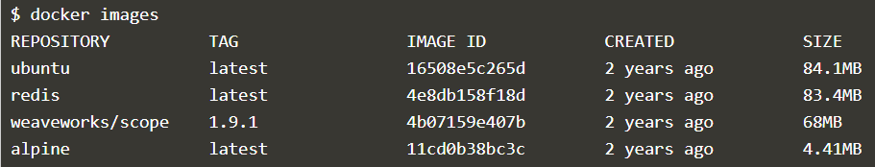

Use $docker search <imagename> command to search for the images available for download.

$docker search redis – For searching Redis Images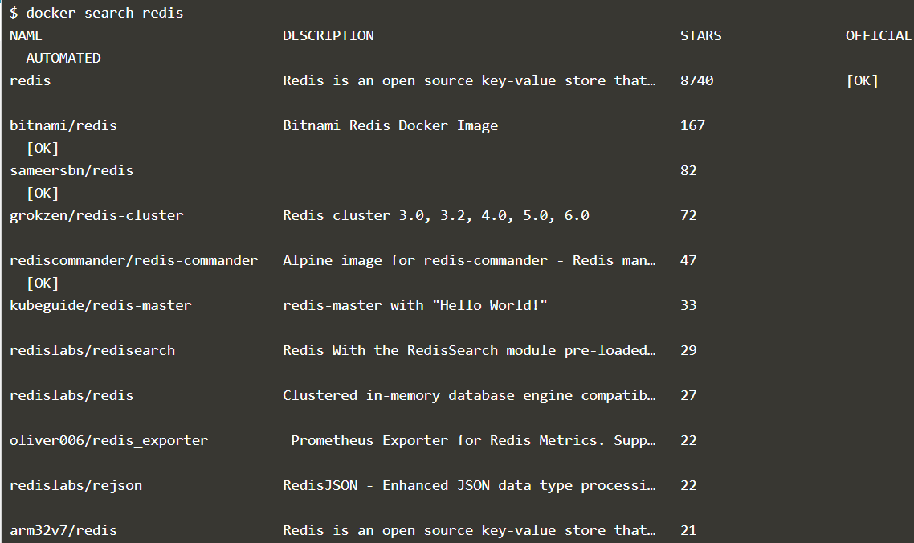

Use $docker pull <imagename> to download a Docker Image

$docker pull arm32v7/redis

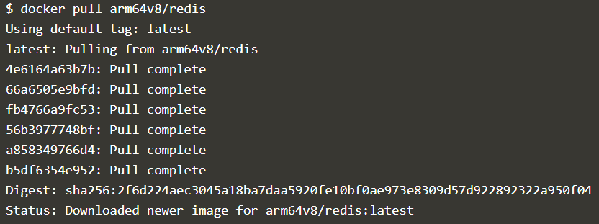

arm32v7/redis image has been downloaded

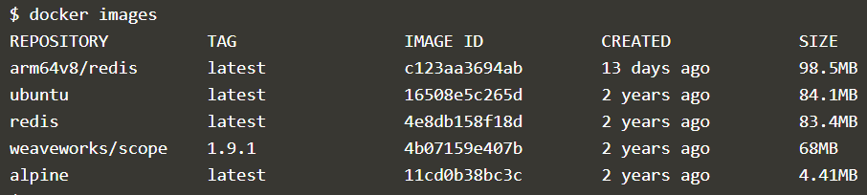

Use $docker run -d <imagename> to run the docker image and -d is used to keep it running in the background. Same images can also run multiple times.

$docker run -d redis



Use $docker ps to see all the images that are only running currently in your machine.

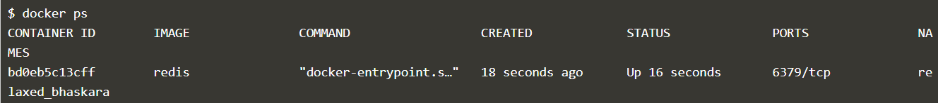

Use $docker ps -a to see all the images that are running and terminated.

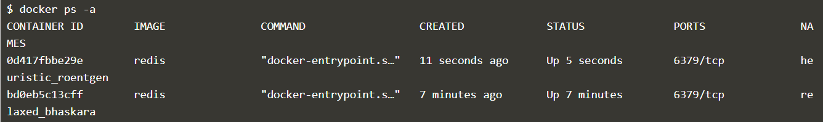

$docker inspect <container name or container id> provides more details about a running container, such as IP address.

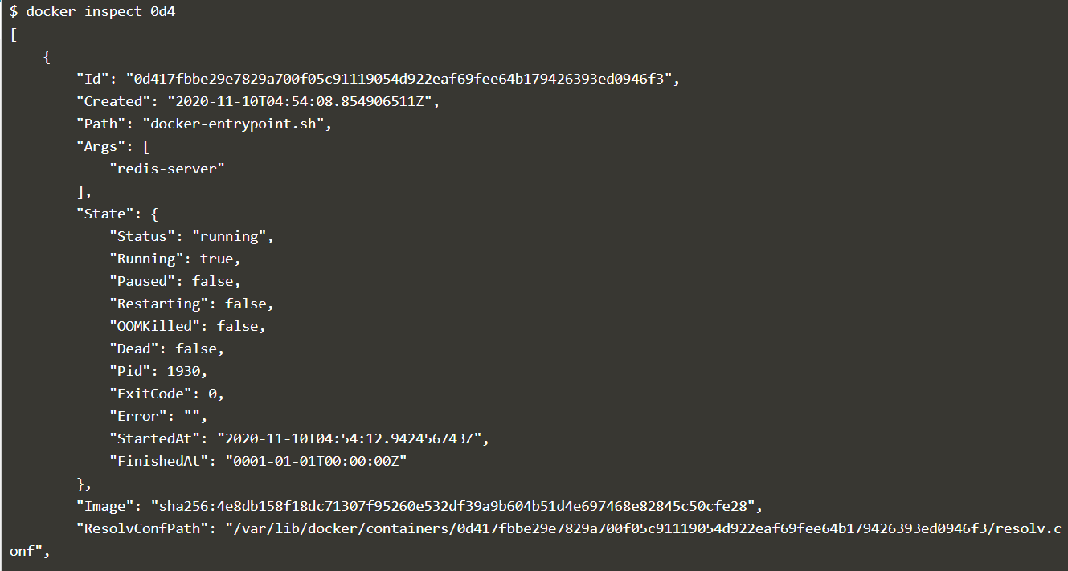

Use $docker run -d --name redisHostPort -p 6379:6379 redis:latestlatest to define customized docker image names and ports.



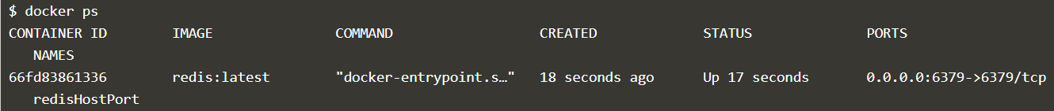

Use $ docker run -d --name redisDynamic -p 6379 redis:latest to define random port.

$docker port to see the assigned port

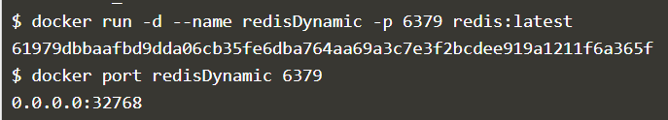

$docker ubuntu run ps command launches an Ubuntu container and executes the command ps to view all the processes running in a container.

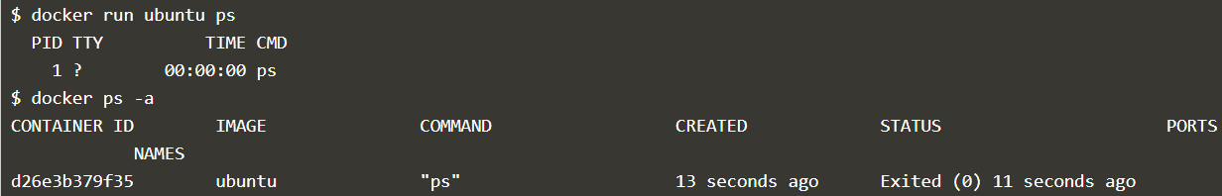

$docker run -it ubuntu command allows to get access to a bash shell inside of a ubuntu container.

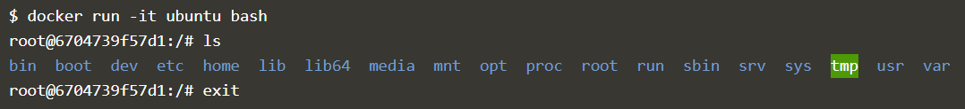

$docker stop



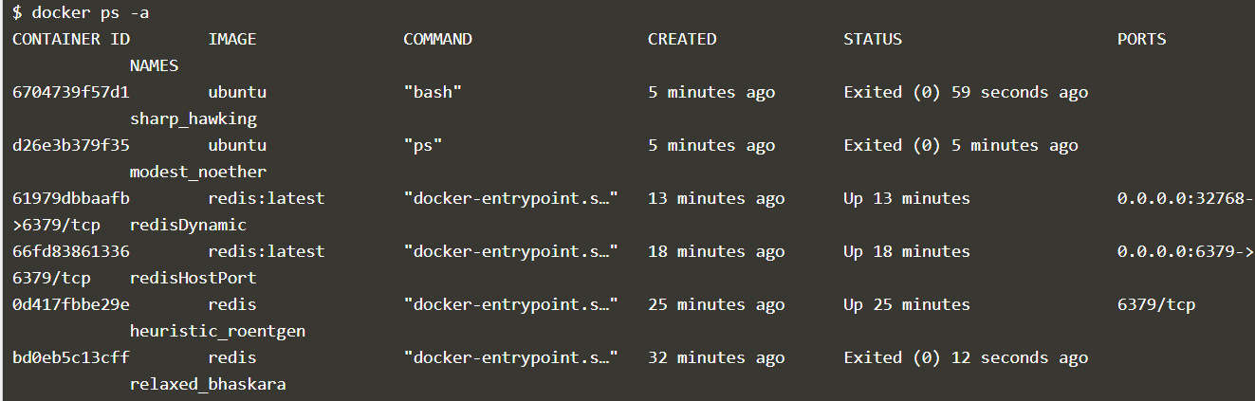

$docker start

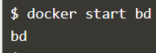

**Docker Volume**

Starting Vagrant

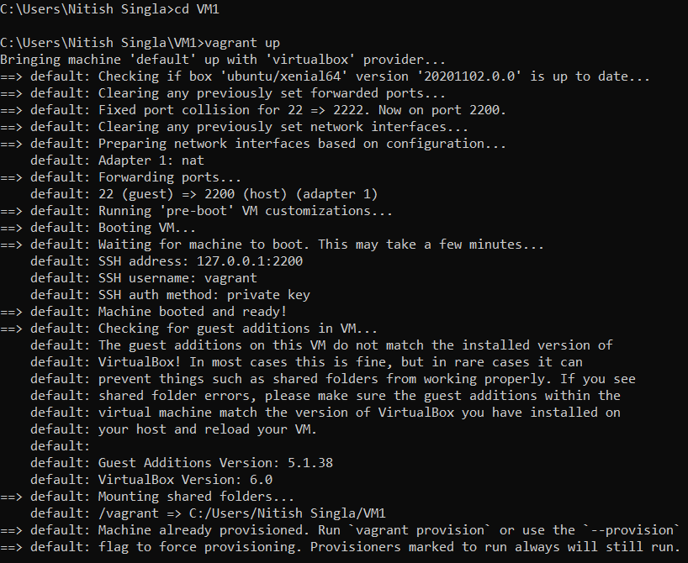

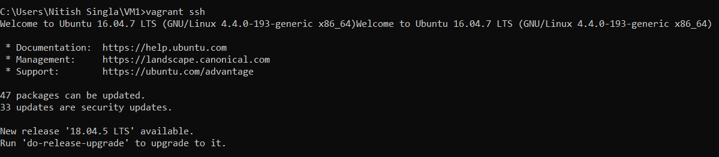

Running Docker Alpine Image $docker run alpine

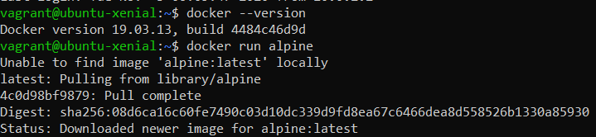

$docker ps and $docker ps -a to see the containers running or terminated

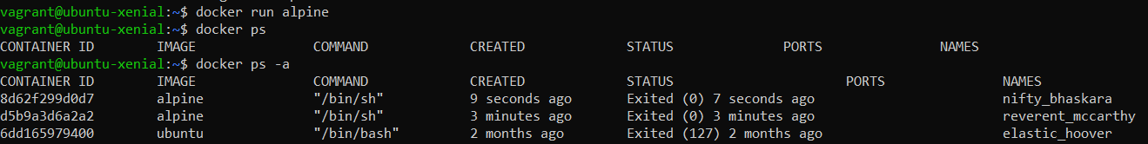

$docker run -it alpine

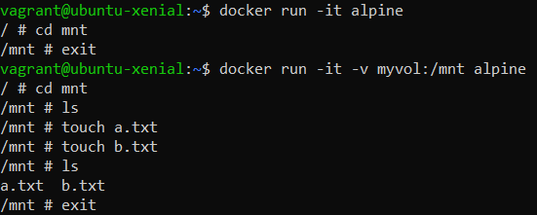

$docker run -it -v myvol:/mnt alpine to create a docker volume

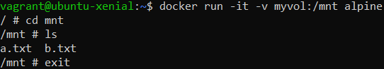

$docker volume ls to list docker volumes

